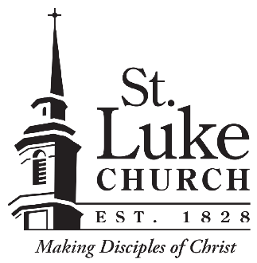

St. Luke Church
Position Description

Position Title: | Banquet Captain
Reports to: | Director of Events
Position Summary: Responsible for setting up, servicing and maintaining banquet events per BEOs, utilizing contracted staff and St. Luke employees to achieve results to provide the highest quality of service to guests in an attentive, courteous and efficient manner.
Duties and Responsibilities:
- Oversee and supervise all events and meetings and manage staff by assigning tasks or services to team members, ensuring that safety and sanitation codes are followed
- Work with Ministry Center Assistant to arrange for staff at events as needed based on information from BEO. Ensure staff is rotated regularly to maintain full labor pool.
- Direct activities of staff during set-up, throughout the event, and afterward for clean-up. Be familiar with the organization of each event and maintain a thorough knowledge of service preferences as required. Ensure that tables and buffets are kept stocked and appealing for guests.
- Maintain an inventory of all dinnerware (glasses, silverware, plates, etc.) as well as dry stock.
- Ensure all rooms across campus are clean and set up appropriately before guests arrive for each event, including dining tables, food and beverages.
- Liaison with the host regarding the timing of the meal and any other information needed; touch base with host during the event to respond to any special requests or unanticipated adjustments.
- Monitor activities of staff and guests and respond to questions, complaints or comments that may arise.
- Supervise clean-up, inventory and storage of supplies and equipment. Ensure all items (dishes, silverware, linens, etc.) are properly cleaned and put away immediately following each event.
- Maintain a warm and friendly demeanor at all times and ensure staff is attentive, friendly, helpful and courteous to guests and fellow staff.
- Note that work schedule may vary depending upon event schedule. Night and weekend work required.
- Other duties as assigned
Skills/Qualifications:
- Growing Christian
- Supervisory experience in a related field
  - Familiarity with all styles of table service
- Professional, friendly demeanor with excellent customer service and communication skills
- Ability to work well in stressful, high-pressure situations, with the ability to anticipate, identify, prevent and solve problems

