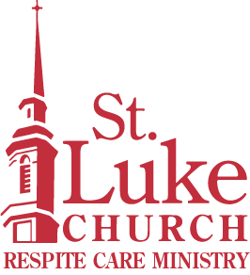
St. Luke Church
Position Description
Respite Care Ministry

To submit your resume and cover letter, please email it to
Kathryn Fussell, Director of Respite Care at kfussell@stlukecolumbus.org.

Position Title: | Respite Care Program Assistant
Reports to: | Director of Respite Care
Position Summary: Assists with daily operations of the programs, services and activities of the Respite Care Ministry including assisting with community and Respite Care Ministry volunteers.
Duties and Responsibilities:
- In conjunction with Director, plan and carry out daily schedule of activities for participants.
- Document participants daily in log book.
- Provide feedback and information to families regarding participant’s experience at Respite Care.
- Assure safety measures are observed. Notify Director immediately of any possible medical emergency.
- Attend training and continuing education as appropriate.
- Provide input to Director regarding program needs, equipment or facility to enhance program.
- Maintain current CPR certification.
- In absence of Director, assume the duties of Director for safe operation of the program.
- Other duties as assigned.
Skills/Qualifications:
- High school diploma required; college degree preferred.
- Excellent communication skills.
- Ability to work with older adults.
- Experience in Human Services field.
- Ability to plan and execute activities.
- Maturity; emotional stability.
- Flexibility.


